CRM 2011 Plugins – Avoiding Infinite Loops
When developing plugins for Microsoft Dynamics CRM 2011, there are scenarios in which the execution of your custom code can result in an infinite loop. This leads to unnecessary execution of plugins and can potentially impact the performance of CRM, as well as the user experience. In this post, we will take a look at the Depth property of the IPluginExecutionContext service object and see how it can be used to eliminate the risk of infinite loops.
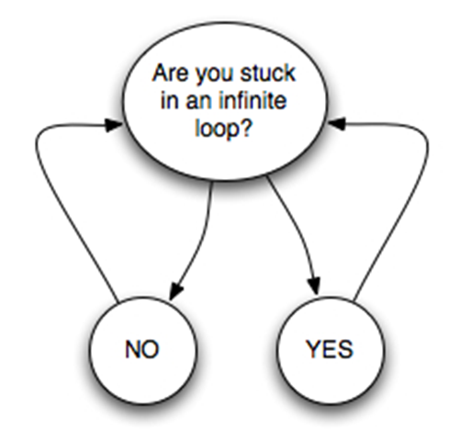*
Before we see how to use the Depth property, let’s take a look at a scenario. Assume your CRM implementation consists of the Contact entity and a custom entity called Member. The requirement for the system is to keep data on the Contact and Member entities synchronised, so that the following business rules apply:
1. When a Member is created, a corresponding Contact record is created (if one does not already exist)
2. When certain details on the Member is updated, details on the corresponding Contact record must also be updated
3. When certain details on the Contact record is updated, details on the corresponding Member record must also be updated
You can see that this type of business logic will require a plugin to be registered on create of Member, and on update of both Contact and Member. You will also notice that updating a Member triggers an update of the Contact, which again triggers an update of the Member and so on.
Firstly, let’s see what happens if we deploy such a plugin without any consideration for handling infinite loops. I have updated the “Full Name” field on the Member, which should try to update the “Full Name” field on the Contact.
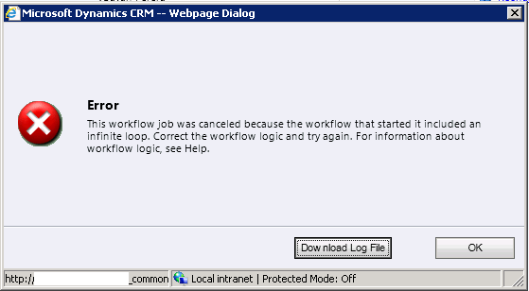
The CRM platform throws an error stating that it has identified an infinite loop. This usually happens after the number of iterations reaches a maximum of 8. We can fix this by adding a depth check at the start of our plugin code, just after we initialize each of the service objects.
IpluginExecutionContext context = (IPluginExecutionContext)serviceProvider.GetService(typeof(IPluginExecutionContext));
IOrganizationServiceFactory factory = (IOrganizationServiceFactory)serviceProvider.GetService(typeof(IOrganizationServiceFactory));
_sdk = factory.CreateOrganizationService(context.UserId);
ITracingService tracer = (ITracingService)serviceProvider.GetService(typeof(ITracingService));
if (context.Depth > 1) { return; }
Notice that last line which checks if the plugin has run more than once, and if so, executes a return statement to cancel out of the plugin. Now when we run the plugin, we shouldn’t run into an infinite loop.
You must be careful when using the Depth property as there are more complex scenarios that you may run into. For example, a data import may trigger a workflow to update the “Full Name” of a Member, which in turn will execute our plugin. In this case, the Depth will be 3 at the first execution of the plugin. If you left the code snippet above unchanged, the plugin logic will never get executed.

Business Scenario:
Let’s say a user was creating an invoice, and then invoice details. As part of this client’s requirements, there was heavy customization on these entities on create and update what would update the entity itself, the parent entity, and other related entities. The core of their business operations were in the order processing entities.
When a user clicks save, the context.depth (an integer value used by CRM to track how many calls to the CRM web service is being made in a single transaction) is 1. CRM uses the depth value to prevent an infinite loop, because for each call to the CRM web service, the depth is incremented by 1. Now let’s say within that transaction, a plug-in is fired to update another record, the depth value is increased to 2. If the depth value keeps increasing and reaches a CRM 2011 on-premise configured limit of 8, an error is thrown saying there’s an infinite loop. This was an issue for our client because of the heavy processing that was needed on the order processing entities.
Solution:
Eventually I had to reach out to my friends in Microsoft because I never had to deal with this before. Apparently in CRM 2011 online, the limit is configured at 16. For on-premise, the limit is by default 8. After talking to MS support, they had recommended us increasing the limit to 16 to match the online version. To do this, we ran a simple SQL update statement against the CRM database:
UPDATE DeploymentProperties
SET IntColumn = 16
WHERE ColumnName = 'MessageProcessorMaximumDepth'
That did the trick! Of course any updates to the database directly is unsupported, but I found it interesting that an MS support agent recommended for us to do this.
For a many-to-many relationship, this method creates a record in the intersect table for the relationship, which contains the ID of both the referenced and referencing records. The intersect table name is defined in the IntersectEntityName property for the relationship.
Logical Name | The unique name of the entity or attribute. This name is all lowercase.
Schema Name | The schema name is specified upon creation. It must be unique. It is used to create the logical name. This name should be in Pascal case. The schema name is used to create the class for the entity when using early bound programming.

Assign
For user-owned or team-owned entities, you assign a record to a new owner. For more information, see Entity Ownership. To perform this action, the caller must have Assign message privileges and access rights on the entity records.

Assign
For user-owned or team-owned entities, you assign a record to a new owner. For more information, see Entity Ownership. To perform this action, the caller must have Assign message privileges and access rights on the entity records.
The cascading rules determine whether related records are assigned to another user at the same time. For more information, see Entity relationship behavior.
When a record is assigned to another user or team, the previous owner still has access to this record if the ShareToPreviousOwnerOnAssign attribute is set to true. However, the previous owner will no longer have ownership of the record.

Share
For user-owned or team-owned entities, you can share a record with other users or teams. To perform this action, the caller must have GrantAccess message privileges, ModifyAccess message privileges, and RevokeAccess message privileges and access rights on the entity records.
The cascading rules determine whether related records are shared at the same time. For more information, see Entity relationship behavior
Sharing is the way Microsoft Dynamics CRM users can give other users access to customer information as needed. For example, a salesperson might decide to share an opportunity with another salesperson so that they can both track the progress of an important sale.
Use the GrantAccessRequest to share a record. Use the ModifyAccessRequest to change how a record is shared. Use the RevokeAccessRequest to remove all sharing for the record.
A user must have share rights to share customer-related records, such as contacts, accounts, opportunities, cases, and orders, with any other user in Microsoft Dynamics CRM. When a record is shared, you can specify the rights to grant for the shared record.
The following list describes the rules for sharing records:
- Anyone with share privileges on a record can share it with additional users or teams.
- Anyone with share privileges on a record can set access rights for that record. These access rights control how a user who shares a record can access that record.
- Access on a shared record can be set to any access right, for example, read or write.
- Access rights on a shared record can be different for each user that the record is shared with.
- A record can be shared with the same security principal only one time. A user can share a record if they have share privileges on that record.
- Anyone with share privileges on a business record can modify the access rights for users who have the record shared.
- Anyone with share privileges on a business record can remove sharing for a specified user who has the record shared.
- Anyone with share privileges on a business record can remove sharing for all users with whom the record was previously shared.

Associate
To perform this action, the caller must have Associate message privileges and access rights on the records that are being updated.
Associate creates multiple associations in one transaction between the specified record and each record in the specified collection for the relationship specified.
For a one-to-many relationship, this method sets the ReferencingAttribute in the related record to the ID of the specified record.
For a many-to-many relationship, this method creates a record in the intersect table for the relationship, which contains the ID of both the referenced and referencing records. The intersect table name is defined in the IntersectEntityName property for the relationship.

Disassociate
To perform this action, the caller must have Disassociate message privileges and access rights on the records that are being updated.
Disassociate reverses the associate operation, by updating the referenced and referencing records and deleting the intersect record where appropriate. For more information, see Associate.

Set State
To perform this action, the caller must have SetState message privileges and access rights on the records that are being updated. The SetStateRequest message updates the StateCode and StatusCode attributes of the entity record.

Entity ownership
There are several types of entity ownership. Most entities, including custom entities, are owned by the organization, by a user, or a team. There are some business entities that do not have an owner, such as discount type (discount list), where the ownership is defined by its parent entity discount. The type of ownership defines some of the operations that can be performed on a record. Ownership for an entity is defined in the metadata property OwnershipType. The following table lists the ownership properties.

Ownership Type | Description
Organization Owned | Contains data involving something that belongs to or that can be viewed by the whole organization. Organization-owned entities cannot be assigned or shared. For example, products are owned by the organization. These entities have an attribute named organizationid.
Business Owned | Entities that belong to a business unit. These entities have an attribute named owningbusinessunit.
User or Team Owned | Assigned to a user or to a team. These entities contain data that relates to customers, such as accounts or contacts. Security can be defined according to the business unit for the user or team. These entities have attributes named owningteam and owninguser.
None | These entities are not owned by another entity.

Synchronous vs. Asynchronous Plug-ins
Synchronous plug-ins are executed by the CRM Core System. Synchronous execution means that triggering event will wait until the plug-in finishes the execution. For example, if we have synchronous plug-in that triggers on the creation of account and user creates account record in CRM, the form will hang at save until the plugin has finished.
Asynchronous plug-ins are executed by asynchronous service. Asynchronous plug-ins allow triggering event to finish before plug-in code runs. Therefore these can never be used to prevent an action, validate data entry, or provide any error messages back to the user.

Plug-in vs. Processes
These are very similar, in fact workflows are just a skin on an asynchronous system plug-in. The main differences:
- Workflows can only be triggered asynchronously
- Workflows can only be triggered online
- Workflows have limited triggers. Mostly these would be your basic create/update/delete/assign/state change.
- Plugins support different event execution pipelines. Workflows are always post operation.
- Workflow execution logic can be easily modified, this allows encapsulation of code in custom workflow activity while still retaining possibility of frequent changes on execution logic by non-programmers.
http://crmbook.powerobjects.com/extending-crm/plug-in-development-and-workflow-extensions/plug-ins/registering-and-deploying-plug-ins/ ---- important book

PreEntityImages and PostEntityImages In CRM 5.0 / 2011 Plugins

i

7 Votes

PreEntityImages :
It is basically used to capture the data when the form loads. That is the data which is present by default when the form loads. The syntax for using the PreEntityImages in CRM 2011 is changed as compared to CRM 4.0. Remember the PreEntityImages cannot be registered for “create” operation.
Syntax Used in CRM 2011 :
Suppose you registered the Plugin and added a Image with name “PreImage ”
Entity preMessageImage;
if (context.PreEntityImages.Contains(“PreImage”) && context.PreEntityImages["PreImage"] is Entity)
{
preMessageImage = (Entity)context.PreEntityImages["PreImage"];
accountnumber = (String)preMessageImage.Attributes["accountnumber"];
}
Here Entity is an Class that is available in the Microsoft.Crm.Sdk.dll
PostEntityImages :
The Post Image contains the attributes value which are finally changed. We can capture the changed data before the database operation takes place. And can do any kind of validation based on the changed data. Remember it can only be registered for update message and cannot be registered on create message.
Syntax Used in CRM 2011 :
Suppose you registered the Plugin and added a Image with name “PostImage ”
Entity postMessageImage;
if (context.PostEntityImages.Contains(“PostImage”) && context.PostEntityImages["PostImage"] is Entity)
{
postMessageImage = (Entity)context.PostEntityImages["PostImage"];
accountnumber = (String)postMessageImage.Attributes["accountnumber"];
}
The PreEntityImages and PostEntityImages are Very useful in Scenarios where we want to compare the data that is changed by the user. Based on the changes the custom operation can be performed.
The below PLugin shows the use of PreEntityImages and PostEntityImages.The plugin creates a contact record when a account record is updated. The plugin uses late binding or Dynamic Entity concept for the creation of the record.
